1085-25 (Trg O)

608 “Duke of Edinburgh” Royal Canadian Air Cadet Squadron
PO Box 22022
Belleville

25 Apr 2022

Distribution List

OPERATION SPRING CHICKEN
851/608 SQN SPRING FTX 11-12 JUN 2022

SITUATION

- OPERATION SPRING CHICKEN will be held at the Macauley Mountain Conservation Area at Clarke Rd, Prince Edward, ON K0K 2T0 from 0800hrs to 2100hrs on Saturday, 11 Jun 2022 and 0800hrs to 1800hrs on Sunday, 12 Jun 2022.

- 851 Sqn will participate in Day 1 and Day 2; and

- 608 Sqn will participate in Day 1.

- In accordance with the course training plan and mandatory support training requirement, 851/608 Sqn will conduct an outdoor training event to fulfill training requirements for PO X90. This also allows the cadets to get out of the virtual/in-person classroom and put into practice what they have learned over the past training year.

- The activity will take place in one of Ontario’s Conservation Areas. An approved outdoor and indoor facility used by 851 Sqn as a local training facility that will ensure proper social distancing measures are being adhered to.

- 50 cadets and 10 adult staff (6 male/4 female) are expected to attend.

MISSION

- 851 “Prince Edward” Squadron and 608 “Duke of Edinburgh” Squadron will conduct OPERATION SPRING CHICKEN on Saturday and Sunday, 11-12 Jun 2022 in order to satisfy PO 190, PO 290, PO 390 & PO 490.

EXECUTION

- The cadets are to arrive at the training site on Saturday morning and conduct the scheduled training. The schedule is round-robin style with four (4) crews with four (4) classes in the afternoon on Saturday. Cadets will leave the site NLT 2000hrs. 851 Sqn will arrive at the training site Sunday to conduct Day 2 of training. Volunteer cadets will be asked to tear down any remaining equipment.

- An advance party will be provided by 851 Sqn on Friday evening and no overnight activities will be conducted by staff and cadets throughout the weekend.

- Security of kit & equipment is the responsibility of each individual.

- The schedule of the activity (Annex A)

- Map of the site (Annex B)

- Personnel Tasking Description (Annex C)

- Work schedule (Annex D)

SERVICE SUPPORT

- Transportation – School Bus(es) will be requested by 608 Sqn travelling from the Belleville Armouries to Macauley Mountain Conservation Area on Saturday 11 Jun 22 and travelling back in the evening. 608 Sqn cadets are to be dropped off to the Belleville Armouries Saturday morning at 0830hrs. 851 Sqn cadets are to be dropped off at Macauley Mountain Conservation Area NLT 0900hrs. All cadets will be picked up NLT 2100hrs on Saturday evening and will be picked up by their parents/guardians.

- Support Vehicles – At least one (1) staff vehicle will be available as a safety vehicle and will be available throughout the weekend in case of an emergency. No DND vehicle will be requested due to staff vehicle and close proximity to local medical facility for emergency services.

- Rations – A combination of MRE, MRE Supplement, and/or Non-DND Facilities – Bulk Food Purchase will be requested individually by 851 Sqn and 608 Sqn from Trenton quartermaster.

- Accommodations – No overnight accommodations requested.

- Equipment – Requested equipment list (Annex E) from Trenton quartermaster. Equipment to be dropped off and picked up from training site by Trenton quartermaster.

- Unit equipment (Annex F)

- Cadet kit list (Annex G)

- Other Support – Estimated Cost to be $0 for support facility as it is 851 Sqn local training facility.

- In case of an emergency, medical or otherwise, all personnel will cease training and regroup until situation is dealt with. Any personnel involved in or witness to an injury will call out “No Duff, No Duff, No Duff, your call sign, I have an emergency message…” and give their locations. The situation will be relayed over the radio net and the net will cease traffic other than those dealing with situation. Depending on the severity of the incident, the involved cadet shall be evacuated to the parking lot and await emergency services. The medical officer will maintain command until situation is complete. In the event of a less serious incident, the OIC/Medical Officer will determine by what means and to where the cadet receives medical attention. Cadet health cards are to be available at all times in the event of an emergency. Parents and SEOA Area Office (if required) will be informed after the urgency of the situation had passed.

- First Aid will be administered by those qualified/certified under the direction of the medical officer; preferably by staff.

- Closest medical facility is Quinte Healthcare - Prince Edward County Memorial Hospital located at 403 Picton Main St, Prince Edward, ON K0K 2T0. 2.6km from training site.

- Dress for activity for officers will be CADPAT/NCD. Cadets will wear the Field Training Uniform (FTU) or appropriate civilian clothing.

COMMUNICATION AND COMMAND

- Hand held radios will be requested from detachment for all training sites, command/first aid, and roaming staff. Frequencies will be determined on-site. At least two (2) working cellular phone will be available in case of emergencies.

- At least two (2) working cellular phone will be available in case of emergencies. Emergency Contact for 851 Sqn will be Capt Campbell (613) 242-7035. Emergency contact for 608 Sqn will be Capt Leadbeater (613) 827-2320.

- Police, Paramedics and Fire Department can all be reached by dialing 9-1-1

//signed//

J.R.G. Leadbeater
Captain
Commanding Officer
608 Duke of Edinburgh RCACS
Annexes:

Annex A Training schedule
Annex B Diagram of the site
Annex C Personnel Task Description
Annex D Work Schedule
Annex E Requested Equipment List
Annex F Unit Equipment List
Annex G Cadet Kit List

Distribution List
Action

SEAO Office Trenton
RCSU (C)
Trg O
Sup O
Adm O
Cdt Cmdr
Cdt 2IC
Instructors

Information

851/608 Squadron Sponsoring Committee

ANNEX A – TRAINING SCHEDULE

SATURDAY 11 JUN 2022
TIME | ACTION | IN COMMAND | 2IC
0800 | Adult staff arrive | OIC | 2IC
0830 | 608 Sqn arrive Belleville Armouries | 2IC | Cdt 2IC
0900 | 608 Sqn depart Belleville Armouries | 2IC | Cdt 2IC
0935 | 608 Sqn arrive at training location | 2IC | Cdt 2IC
0945 | Attendance | Admin O | OIC
1000 | Safety Briefing | OIC | Safety O
1100 | Set-up training site | Cdt Cmdr | Cdt 2IC
1200 | Lunch | Quartermaster | Cdt 2IC
1300 | Class 1 | Trg O | Trg O 2IC
1400 | Class 2 | Trg O | Trg O 2IC
1500 | Class 3 | Trg O | Trg O 2IC
1600 | Class 4 | Trg O | Trg O 2IC
1700 | Dinner | Quartermaster | Cdt 2IC
1800 | Stand easy | Cdt Cmdr | Cdt 2IC
1900 | Tear-down training site as necessary | Cdt Cmdr | Cdt 2IC
2000 | 608 Sqn Depart training location | 2IC | Cdt 2IC
2035 | 608 Sqn Arrive Belleville Armouries | 2IC | Cdt 2IC
2100 | 608 Sqn Dismissal | 2IC | Cdt 2IC

SUNDAY 12 JUN 2022
TIME | ACTION | IN COMMAND | 2IC
 | Adult staff arrive | OIC | Cdt Cmdr
 | Attendance | Admin O | OIC
 | Safety Briefing | OIC | Safety O
 | Set-up | Cdt Cmdr | Safety O
1200 | Lunch | Quartermaster | Trg O 2IC
 | Skills review | Trg O 2IC | Cdt Cmdr
 | Skills confirmation | Trg O 2IC | Cdt Cmdr
 | Tear-down training site | Cdt Cmdr | Trg O 2IC
1700 | Dinner | Quartermaster | Trg O 2IC
 | Dismissal | OIC | Safety O

ANNEX B – DIAGRAM OF THE SITE

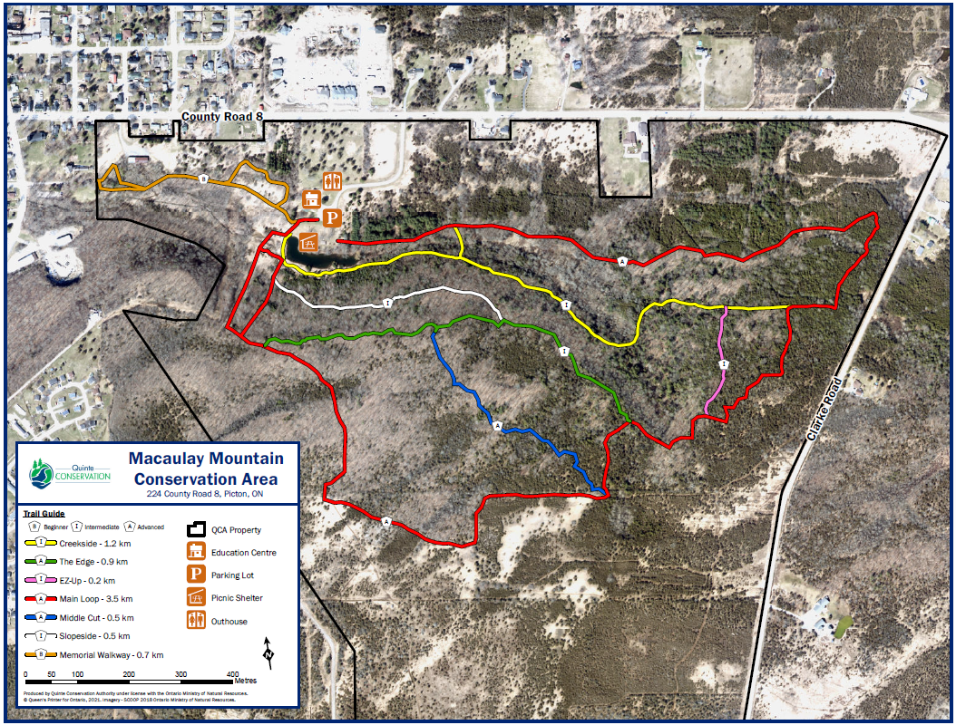
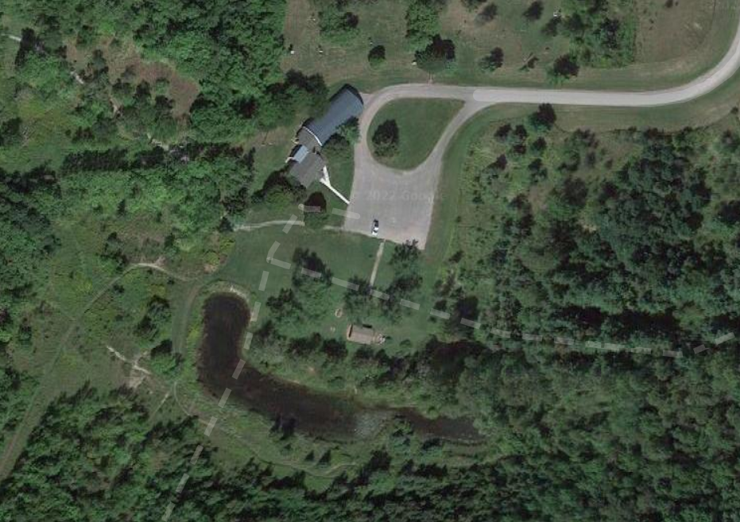
ANNEX C – PERSONNEL TASK DESCRIPTION

2IC – Second-in-Command
Assist OIC with execution of exercise
Distribute Operations Order (Ops O) to all participants three (3) weeks prior to exercise.

Trg O – Training Officer
Assign instructors to classes.
Provide instructors with IG’s for classes.
Ensure instructors are prepared to deliver a high-quality, exciting, and informative class.
Evaluate instructor performance and provide feedback.
Prepare alternate training plans in case of situation changes i.e. poor weather.
Complete cadet training files upon successful completion of FTX

Adm O – Administration Officer
Create a sign-up list four (4) weeks prior to FTX and begin signing staff and cadets up.
Print-out Cadet Medical Information Summary with cadets that have participation limitations.
Prepare DND 2299 Report on Injuries or Exposure to Toxic Material – Cadet or Civilian Instructor forms
Prepare CF-52 Claim Forms two (2) weeks prior to FTX (see OIC)
Print-out FTX nominal roles including staff and cadets for every meal for CF-52.
Ensure staff & cadets sign the nominal roles upon arrival at training site.
Assist Trg O with duplicates/copies of required instructional material.
Submit completed DND-2299’s, CF-52’s and signed nominal roles to OIC.

1st Aid O – Medical Officer
Make a confidential summary list of all cadets with medical conditions to have on hand.
Collect all cadets’ health cards prior to start of activity – return upon completion.
Collect up-to-date Medical Information Summaries from Adm O prior to departure.
Collect all cadet medications with instructions prior to departure from armoury.
Ensure you have an ample stock of CF-98’s and DND-2299 forms on-hand for activity.
Dispense medications during activity as per instructions.
Administer first aid as required.
Assist OIC in preparation of CF-98’s and DND-2299’s when required.
Advise OIC of any environmental concerns keeping in mind the safety of all personnel.

Safety O – COVID-19 Safety Officer
Ensure proper safety protocols are being followed as per COVID-19 Safety Officer TORs.
Assess security/safety risks associated with FTX and advise OIC two (2) weeks prior to FTX.
Make recommendations to OIC as above.
Keep a constant and accurate head count at all times during FTX.
Ensure no fraternization is occurring.
Ensure no unsafe behavior is occurring.
Ensure secure storage of equipment
Deal with any security and/or safety issues as they come up.
ANNEX D – WORK SCHEDULE
POSITION | NAME
OIC | Capt Campbell
2IC | Capt Leadbeater
Trg O | Capt Howard
Trg O 2IC | CI DeCastris
Adm O | CI Paz
1st Aid O | Capt Russell
Safety O | Capt Foulds
Quartermaster | 2Lt Pekilis
Public Affairs | Capt Bambrough
Cdt Cmdr | 851 WO1
Cdt 2IC | 608 WO1
Cdt Class #1 Senior Instructor
Cdt Class #2 Senior Instructor
Cdt Class #3 Senior Instructor
Cdt Class #4 Senior Instructor
Cdt Cohort 1 Leader
Cdt Cohort 2 Leader
Cdt Cohort 3 Leader
Cdt Cohort 4 Leader

ANNEX E – REQUESTED EQUIPMENT LIST

DESCRIPTION | QTY REQUESTED
COMPASS | 10
AIR MATTRESS | 30
ARCTIC 5 MAN TENT | 2
WIND PANTS (ADULT SIZES)
QTY:
SMALL-
MEDIUM-
LARGE-

SLEEPING BAG  (INNER AND OUTER ARE ONLY FOR OCT-MAY TEMPERATURE) | 30
SLEEPING BAG LINER | 30
SUMMER TENT  (FOR NON-FROST/SNOW TEMPERATURE) | 8
MOD TENT FRONT | 2
MOD TENT CENTRE | 4
MOD TENT REAR | 2
PURLONS | 12
A-FRAMES | 6
MOD TENT STAKING PINS | 12
COLEMAN STOVE | 4
COLEMAN LANTERN | 12
POT SET | 4
TURKEY COOKER | 4
COFFEE URN | 1
WATER JUGS | 2
WATER – JERRY | 8
WASH BASIN | 8
FIRE EXTINGUISHER | 2
STRETCHER | 1
FIRST AID KIT | 2
FLASHLIGHT | 15
SLEDGE HAMMER | 2
TREE SAW | 1
AXE | 1
PARKA (ADULT SIZES)
QTY:
SMALL-
MEDIUM-
LARGE-
BLACK MUKLUKS
YELLOW RAIN PONCHO | 25
ARCTIC MITS
SNOW SHOES
SHOVEL | 2
BALACLAVA
WOOL BLANKET | 5
RADIOS (HAND HELD) | 15
ARCTIC TOBOGGAN
HIKING BACK PACK
CONSUMABLES
DESCRIPTION | QTY REQUESTED
PAPER TOWEL | 10
TOILET PAPER | 20
NAPTHA – 4 LITRE | 4
PROPANE – BBQ | 4
GLOW STICKS | 50
DISH SOAP | 4
MRE 1 CASE = 12 MRE | 8
SUNCREEN | 15
BUG REPELLANT | 15
MATCHES | 1 box
FOOT POWDER | 15
CHAPSTICK | 30
HAND SANITIZER | 6
LANTERN MANTLES | 6
MATTRESS PLUGS | 30

ANNEX F – UNIT EQUIPMENT LIST

DESCRIPTION | QTY
Sports Equipment
Compass
Whistle
Map
GPS
Tukey Cooker
Cooler
ANNEX G – CADET KIT LIST

The following items are required for participation in the Field Training Exercise (FTX). A gear check will be performed before departure to the FTX site. Failure to possess ANY of the essential items may exclude you from participation in event. This list is a MINIMUM. All participants are responsible for their own gear; any lost or stolen items are the sole responsibility of the participant.

MANDATORY

- OHIP/Health card (original only)
- 2+ Non-Medical Mask
- 1 brimmed hat (i.e. Baseball cap)
- 1 refillable water bottle/canteen

WEARING

- Wedge or AF blue beret with Air Cadet cap badge, cadet tilly hat, or cadet toque
- AF blue t-shirt
- Coat, Field Training Uniform (FTU)
- Trousers, Field Training Uniform (FTU)
- Boots, multipurpose
- Cadet rank slip-ons
- Belt
- Pair of socks
- Set of underwear

PACKED

- 1 bag to carry all the below items
- Any prescribed medication, medical history summary with allergies (if applicable)
- 1 pair of running shoes
- 2 pairs of socks
- 2 sets of underwear
- 1 outdoor/rain jacket
- 1 pair rain pants (optional)
- 1 sweater
- 1 pair pants (NO JEANS)
- 1 long sleeve shirt
- 1 short sleeve shirt
- 1 notepad and pen(cil) in a re-sealable bag (to keep dry)
- 1 toque (fall/winter)
- 1 pair glove (fall/winter)
- Hygiene kit (soap, toothbrush, toothpaste, deodorant, etc.)
- 1 washcloth
- 1 large garbage bag (for any wet items)

OPTIONAL

- 1 folding chair (highly recommended)
- 1 flashlight
- 1 pair sunglass
- 1 pair work gloves
- Sunscreen, insect repellent, lip balm
- Games, cards, books etc.
- Electronic devices – Cell phones, Music players, cameras.
- Dietary snacks

FORBIDDEN

- CADPAT
- Knives (Sgt+ approved by adult staff)
- Matches, lighters, or other fire starters, pyrotechnics
- Illicit substances (drugs, alcohol, etc.)
- Bear, dog, or pepper spray
- Any other item deemed unsafe by an Officer

