ARMCHAIR TRAVEL
Guided by pilot, photographer & adventurer
Lola Reid Allin
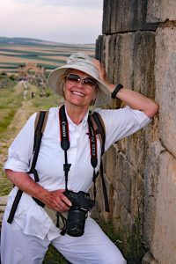
I admit it. I’m addicted to SLOW TRAVEL. Since 1993, I’ve done multi-day camel safaris in India, Tanzania, & Morocco and earned my Dog Mushers Certificate (Yukon). I’ve travelled through 60+ countries and trekked in Spain, Peru, Chile, Canada, and with Guatemalan locals to El Mirador (128 km) & H’mong locals in North Vietnam.
I’ve summited North Africa’s tallest mountain (Morocco) and Kilimanjaro, the world’s tallest freestanding mountain.
Virtually and in person, I have presented to the general public of all ages at libraries, galleries, schools, hotels, as well as private clubs or organizations (99s, Flight student, Air Cadets).
I am a speaker with the Northern Lights Aero Foundation, Eastern Ontario 99s Education & Outreach Committee, & Women’s Travel Network.

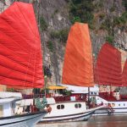
VIETNAM: The Dragon Reunified
Royal palaces. Buddhist temples. French colonial villas. Hideaway beaches. The world’s largest cave. During our exploration of Vietnam, we’ll trek terraced fields with Northern Hill Tribes, bump along the Chinese border on road trip with a former Viet Minh, luxuriate on a junk in Ha Long Bay, navigate Ha Noi’s historic district, walk the DMZ, shop Historic Hoi An’s market for cooking class, visit Hue’s Royal Palaces, and meander the Mekong.
Travel with Lola and discover Vietnam is so much more than rice paddy fields and conical-hatted farmers.

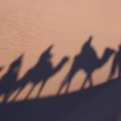
MOROCCO: Sea, Sand and Summit
Join Flygirl Lola on a trek through Morocco, a land of stunning contrasts and hidden jewels. Plunge into the labyrinthine alleys and mesmerizing markets of Marrakech, Casablanca, and Fes, a living medieval city. Venture into Chefchaouen, the once forbidden blue city. Summit Toubkal, North Africa’s tallest mountain. Visit Roman ruins. Travel by camel with Berbers for a multi-day camping safari into the Sahara.

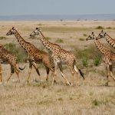
KENYA SAFARI & GORILLA TREK: Into Africa
Feel East Africa seep into your soul as Lola’s photography captures the “Big Five”— lions, leopards, elephants, Cape buffalo, & rhinos — as her safari vehicle bumps through Kenya’s preserved parklands. Hang out with a baboon troop in the shadow of Mount Kenya. Sleep over with the Masai in a manyatta. Step into history at Karen Blixen’s house, immortalized in her 1937 memoir, Out of Africa. Follow legendary Dian Fossey’s footsteps to observe Mountain Gorillas.

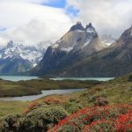
CHILE: Explore Top to Bottom
Our adventure begins in northern Antofagasta Region where Flygirl Lola leads us on a hike the driest desert in the world. We’ll crunch across salt flats, marvel at ancient petroglyphs, and tread carefully through the Southern Hemisphere’s largest geyser field. Moving south, we’ll amble art-festooned laneways in Santiago and Valparaiso then sample Colchagua Valley wines. A flight south takes us to the hiking trails of Torres del Paine in Patagonia followed by a multi-day, small-boat cruise the End of the World at Tierra Del Fuego where we’ll meander with Magellanic Penguins and in the footsteps of Canadian invaders.

BAFFIN ISLAND: Trek the Akshayuk Pass
Join Flygirl Lola Reid Allin and her friends on her personally-narrated, photographic chronicle of their challenging 10-day, 98-km Arctic camping adventure. Trek through snow-covered mountain passes, up and down rocky moraines, and ford twenty-two rushing glacial rivers in Auyuittuq National Park, Nunavut.

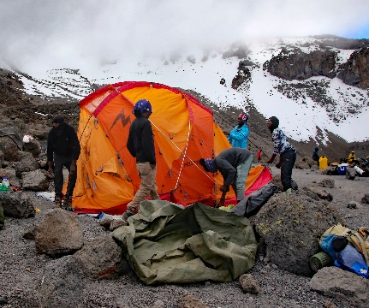

TANZANIA: TREK TO THE SNOWS OF KILIMANJARO & BEYOND
After a successful summit of Kilimanjaro in more snow than the tallest freestanding mountain has received in 20 years, Lola travels to the Serengeti by airplane - which she gets to fly - and on to the exotic Spice Island of Zanzibar.

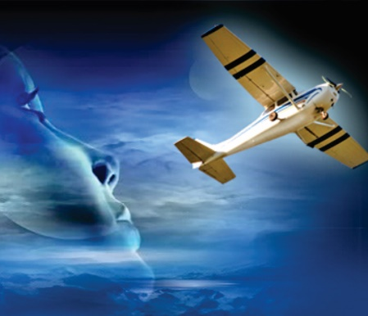
THE SKY’S THE LIMIT
In 1980, Lola attained her commercial pilot license and become one of 200 women in Canada licensed to fly for hire and reward. Lola explains the rewards of an aviation career and the challenges faced by women then and now. She offers several possible reasons why women remain under-represented in commercial aviation (only 5%-7% of pilots are female!) and why aviation or other STEM careers lure few women.

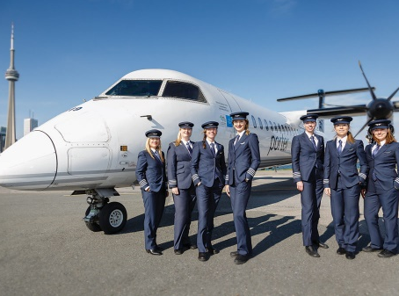
NORTHERN LIGHTS AERO FOUNDATION
By recognizing and celebrating accomplished women, NLAF’s mission is to attract women and inspire them to succeed in careers in aviation and aerospace. NLAF encourages those ambitions by engaging in outreach, facilitating mentorships, providing scholarship opportunities, and championing the values of diversity and inclusion. Founded 2009 by a few Ninety-Nines (International Organization of Women Pilots) from the First Canadian Chapter, under the leadership of the award creator, Anna Pangrazzi. Lola is a speaker for NLAF and Chair of the NLAF Speakers Bureau.

