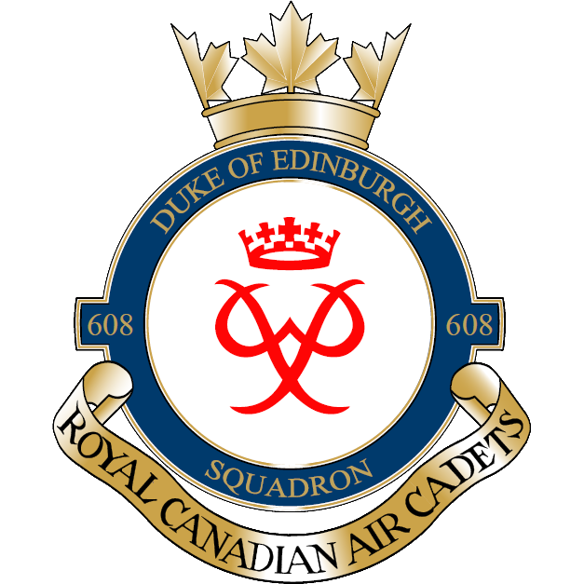

OPERATION NOVEMBER RAIN - FALL FIELD TRAINING EXERCISE (FTX)
Dear parents/guardians,
On Saturday-Sunday 2_3 November 2019, 608 Duke of Edinburgh Air Cadet Squadron will be conducting a Fall FTX to satisfy the Mandatory Aircrew Survival Performance Objective. It will take place at Camp Sagonaska, Vanderwater Conservation Area. An advance party of senior cadets will take place on Friday depending on adult staff availability. Cadets are to be at the armouries at 0730hrs Saturday Morning with their HEALTH CARDS. The bus is expected to return at 1500hrs (3:00PM) Sunday evening.
Tents, sleeping bags, food will all be provided. Cadets are more than welcome to bring their own sleeping bags and food if there are dietary restrictions. See the attached kit list for items to bring. It is expected to be cold so cadets are to dress in winter outerwear and are reminded they will be outdoors for the duration of the entire exercise.
If you have any questions or concerns, please contact the undersigned.

Sincerely,

Justin Leadbeater
Justin Leadbeater
Captain
Deputy Commanding Officer
608 Duke of Edinburgh Air Cadet Squadron
Call/Text Cell 613-827-2320
Lead_beater@hotmail.com
CADET KIT LIST

The following items are required for participation in the Field Training Exercise (FTX). A gear check will be performed before departure to the FTX site. Failure to possess ANY of the essential items may exclude you from participation in event. This list is a MINIMUM. All participants are responsible for their own gear; any lost or stolen items are the sole responsibility of the participant.

MANDATORY

- OHIP/Health card – original only
- 1 bag to carry all the below items
- Any prescribed medication, medical history summary with allergies (if applicable)
- 1 pair of running/sports shoes (2 if possible)
- 1 pair of ankle boots (weather dependent) (optional)
- 3 pairs of socks
- 3 sets of underwear
- 1 brimmed hat (ie. Baseball cap)
- 1 toque
- 1+ pair of gloves
- 1 set of sleepwear
- 1 sleeping bag (optional)
- 1 pillow
- 1 winter jacket
- 1 pair rain/snow pants (optional)
- 2 sweater/hoodie
- 2 pair pants/track pants (NO JEANS)
- 2 long sleeve shirts; and/or
- 2 short sleeve shirts
- 1 notepad and pen in a re-sealable bag (to keep dry)
- Hygiene kit (soap, toothbrush, toothpaste, deodorant, sunscreen, bug spray, etc.)
- 1 washcloth
- 1 large garbage bag (for any wet items)
- 1 refillable water bottle/canteen

OPTIONAL

- Sunglasses
- Cadet FTUs*
- Board games, cards, etc.
- Electronic devices – Cell phones, Music players, cameras. (To be brought at owner’s expense)

FORBIDDEN

- CADPAT
- Prohibited knives (Only Sgt and up may carry knives approved by the officers)
- Matches, lighters, or other fire starters, pyrotechnics
- Illicit substances
- Bear, dog, or pepper spray
- Any other item deemed unsafe by an Officer

* Senior Cadets (Sergeant and above) are authorized to wear the Canadian olive green Cadet Field Training Uniform (FTU). Headdress (wedge or AF blue beret with Air Cadet cap badge, cadet tilly hat, or cadet toque) and cadet rank slip-ons shall be worn with the cadet field training uniform. Cadet FTUs can be obtained by cadets at their own expense.

