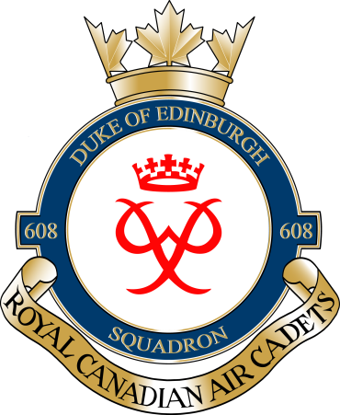

Dear parents/guardians,
This March, 608 Duke of Edinburgh Air Cadets will be participating in our annual March Break Trip. This year’s location is Niagara Falls. The bus will depart from the armouries at 0800hrs on Thursday 17th March 2016 and return at 2100hrs (9:00PM) Friday 18th March 2016.
The cadets will be staying overnight at the Canadian Warplane Heritage Museum and visiting Niagara Falls. Meals will be provided to the cadets. Lunch and dinner on Thursday; breakfast, lunch, and dinner on Friday.
The cost to this trip is going to be $40 per cadet and bus seats will be reserved on a “first-come, first-served” basis.
If you do not have your money in for OPC Tickets, you will not be able to attend.
Attached on the next page is a permission form. Permission form and money is due NLT (No Later Than) Wednesday 24th February 2016.
Thanks,

Captain / capitaine Justin Leadbeater
Commanding Officer, RC(Air)CS 608 Duke of Edinburgh
National Defence / Government of Canada
Lead_beater@hotmail.com / Tel: 613-827-2320
Commandant, RC(Air)CS 608 Duke of Edinburgh
Défense nationale / Gouvernement du Canada
Lead_beater@hotmail.com / Tél: 613-827-2320

