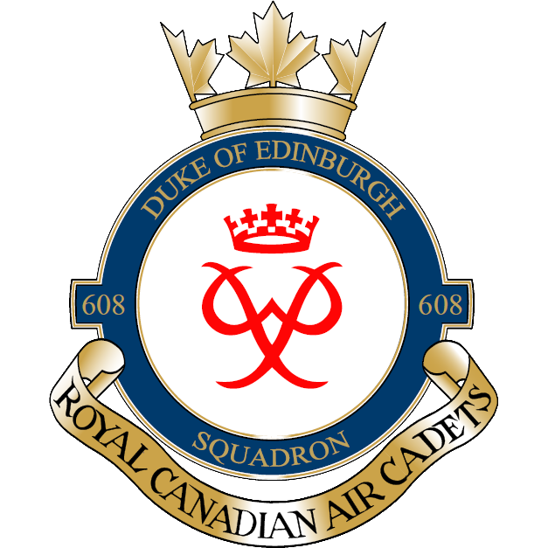

WONDERLAND 28 MAY 16
Dear parents/guardians,
On Saturday May 28th, 608 Duke of Edinburgh will be going to Canada’s Wonderland. The bus is leaving at 0800 hrs and we will be returning at 2100 hrs (9:00PM). The cost for this event is $40. The money is due no later than Saturday May 14th.
Dinner will be provided and cadets will have to bring money or food for lunch. The dress will be appropriate civilian gear.
Any questions can be directed to the undersigned.
Thanks,

Justin Leadbeater
Captain
Commanding Officer
Lead_beater@hotmail.com
613-827-2320

