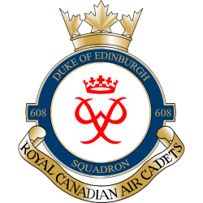
AIRBUS FAMIL FLIGHT 15 MAR 2016
Hello Parent/Guardians,
A Cadet Familiarization Flight has been scheduled for 15 Mar 2016 at 8 Wing Trenton. The flight will be on one of the 437 Sqn Airbuses.

Timings will be as follows: 1030hrs arrival at the AMU and 1200hrs take-off time for a 2-hr familiarization flight. Following the flight, a tour of other aircraft (C-130J, C-17) may be provided if the squadrons are interested.

Detachment will provide a box lunch, and cadets are responsible for arranging transport.

Below is the drop-off/pick-up point:
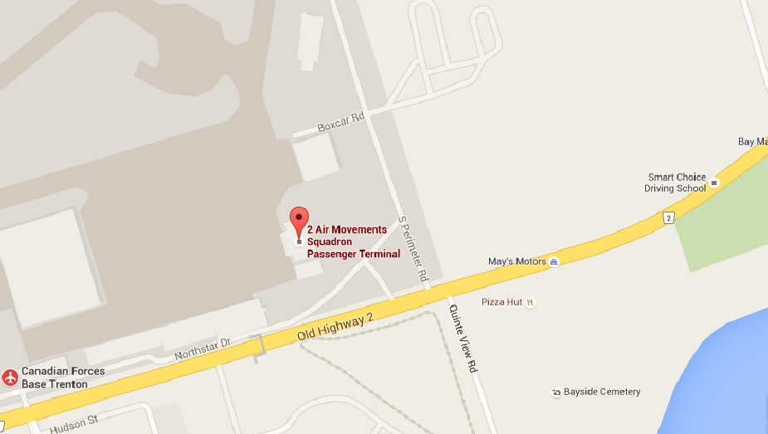

Justin Leadbeater
Captain
Commanding Officer
Call/Text Cell: (613) 827-2320
Lead_beater@hotmail.com

