Lesson 1
Aircraft Design and Construction

- Parts of an Airplane
  - The airplane is defined as:
    - A power-driven heavier-than air aircraft deriving its lift in flight from aerodynamic reactions on surfaces that remain fixed under given conditions of flight.
  - Airplanes are complex structures with many parts.

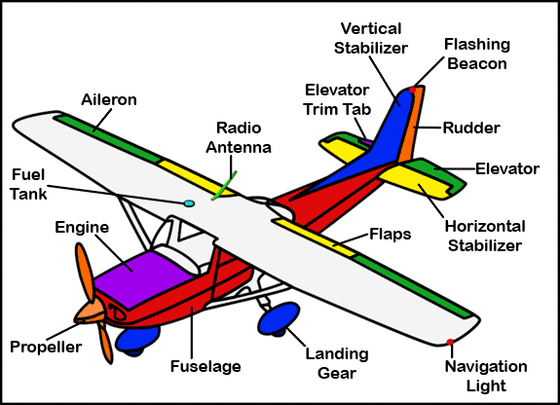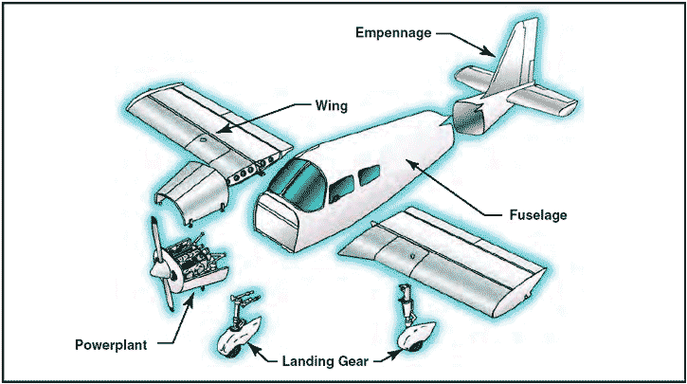

  - Fuselage
    - Main body of the aircraft, where the passengers, cargo, and crew go.
    - Different types of construction:
      - Truss type
        - Longerons
        - Diagonal web members
        - Vertical web members
      - Monocoque
        - Skin only
      - Semi-monocoque
        - Stringers
        - Formers and/or bulkheads
        - Stressed skin
  - Empennage
    - Rear portion of the airplane
    - Integral to control and stability during flight
      - Vertical Stabilizer
        - Rudder
          - Trim Tab
      - Horizontal Stabilizer
        - Elevator
          - Trim Tab
  - Wing
    - Spars
      - Main structural member
      - Carry loads
    - Ribs
      - Web or truss
      - Support skin and give shape
    - Leading and Trailing Edges
    - Wires
      - Further structural support
    - Covering
      - Metal or Fabric
        - Weight vs strength trade-offs
- Aircraft Construction
  - High wing
    - Gravity feed fuel system
    - Increased downwards visibility
    - Increased lateral (roll) stability
  - Mid Wing
  - Low Wing
  - Bi-Plane

- Landing Gear
  - Types
    - Conventional (Tail-dragger)
      - Two main wheels and a tail wheel
    - Tricycle
      - Two main wheels and a nose wheel
        - Advantage in while manoeuvring
        - Advantage in forward visibility on the ground
    - Retractable
      - Wheels move into the fuselage when airborne to reduce drag and increase cruise speed
      - Increased weight, complexity, and potential for failure are trade-offs
    - Fixed
      - Do not retract
    - Floats
      - Fixed to allow water landings
    - Amphibious
      - Floats with retractable wheels to allow for ground landings as well
    - Skis
      - Fixed to allow landing on snow
      - Some designs also allow for wheeled landings
  - Shock Absorption
    - Spring steel landing gear
    - Air/Oil Oleos
    - Rubber cords or discs
    - Low pressure tires
  - Brakes
    - Used for slowing down, as well as steering

- Standard Terminology
  - Wing Span
    - The maximum distance from wing tip to wing tip
  - Chord
    - The imaginary line between the leading edge and trailing edge of the wing
    - Because it is rarely constant throughout the wing, Mean Aerodynamic Chord is measured as an average
  - Wing Area
    - Length of the wing multiplied by the mean aerodynamic chord
  - Planform
    - Shape of the wing as seen from above
    - Different standard patterns exist
  - Aspect ratio
    - Ratio of the span to chord of the wing
    - A measure of how slender the wing is
  - Airfoil
    - A structure curved to produce lift
  - Camber
    - A measure of the curvature of an airfoil
  - Angle of Incidence
    - Angle between chord line and the longitudinal axis
  - Relative Airflow
    - Airflow over the wing
    - Related to the forward motion of the aircraft through the air
  - Angle of Attack
    - Angle between chord line and relative airflow

