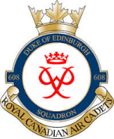

DECEMBER 2018 NEWSLETTER

Dear Cadets, Parents, and Guardians;

As we approach the final days of 2018, I would like to commend the entire 608 family for their commitment and dedication. Our 608 Cadets have done an exemplary job representing the squadron and participating in a full calendar of fall activities.

The following December dates are noteworthy:

Wednesday, 05 December 2018
- CO’s Parade

Wednesday, 12 December 2018
- 608 Annual Mess Dinner at the Officers’ Mess, 8 Wing Trenton
182 Yukon Street, Quinte West, ON
1730hrs – 2030hs
Mess Dress (cadet uniform with white dress shirt and black bow tie)

Wednesday, 19 December 2018
- Holiday Social and Band Concert 1800hrs – 2000hrs
- All Cadets, families and friends are welcome
- Cadets will wear their uniform
- Join us for music, comradeship, and light refreshments

Following the holiday break, we will reconvene on 09 January 2019 with a CO’s Parade.

Some important upcoming dates for January 2019 are as follows:

CO’s Parade – 09 January 2019
Flying Scholarship Exams – 12 January 2019 (for selected candidates)
Biathlon Competition – 19 January 2019
National Course Interviews – 26 January 2019 (for selected candidates)

I wish you all a joyous holiday season.

Sincerely,
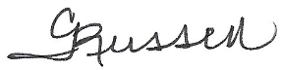
Capt Cynthia Russell
Commanding Officer
608 Duke of Edinburgh RCACS

