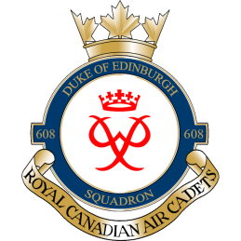
Dear Parents/Guardians,
Below is the kit list for the March Break trip to Hamilton/Niagara Falls. We will be wearing full uniforms (tunic, tie, parka) on day 1 and wearing appropriate civilian clothing on day 2. Due to the nature of the activities we recommend bringing a second set of clothing to change into in case you get wet. Overnight we will be sleeping at the Warplane Heritage Museum in Hamilton. Sleeping bags/air mattresses will be provided by Detachment. There will NOT be shower facilities available. All meals will be provided. Departure at 0800hrs, 17 Mar 16; we are aiming for a late arrival time of 2100hrs (9:00PM, 18 Mar 16).
Item Description | Quantity
HEALTH CARD | 1
Sleeping Bag/personal air mattress (sleeping bags and air mattresses will be provided by Detachment) | Optional
Pillow | 1
Garment bag (garbage bag as substitute if needed) | 1
Hanger (to hang uniform) | 1+
Civilian Clothes
- shoes | 1+
- socks | 2 pairs
- Undergarments | 2
- pants | 2
- shirt | 2
- sweater | 1+
- waterproof jacket | 1
Sleepwear/Pajamas | 1 set
Hygiene kit (deodorant, tooth brush, tooth paste, floss, soap, face cloth, shaving kit [males]) | 1
Spending Money | $$

Justin Leadbeater
Captain
Commanding Officer
Call/Text Cell: (613) 827-2320
Lead_beater@hotmail.com

