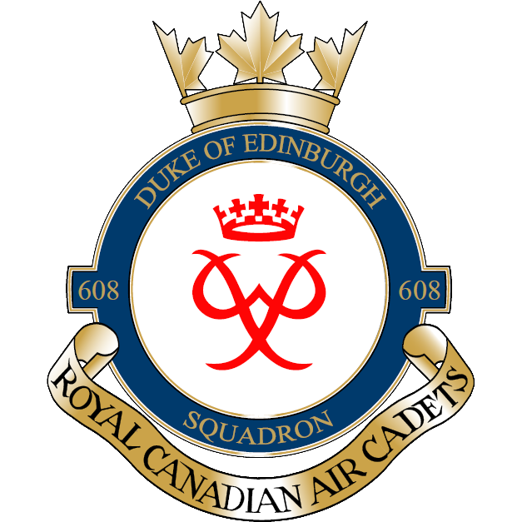

FALL FIELD TRAINING EXERCISE (FTX)
Dear parents/guardians,
On the 12th and 13th of May 2018, 608 Duke of Edinburgh Air Cadet Squadron will be participating in our Spring FTX. The purpose of the exercise is to teach cadets aircrew survival skills. This will take place at Camp Sagonaska, Vanderwater Conservation Area. Cadets are to be at the armouries at 0730hrs Saturday Morning with their HEALTH CARDS. Cadets can will be back at the Armouries and ready for pick-up at 1600hrs Sunday evening.
Tents, sleeping bags, food will all be provided. Cadets may bring their own sleeping bags/tents if they choose so. See the attached kit list for items to bring.
If you have any questions or concerns, please contact the undersigned.

Thanks,

Justin Leadbeater
Captain
Deputy Commanding Officer
608 Duke of Edinburgh Air Cadet Squadron
Call/Text Cell 613-827-2320
Lead_beater@hotmail.com

ANNEX G – CADET KIT LIST

The following items are required for participation in the Field Training Exercise (FTX). A gear check will be performed before departure to the FTX site. Failure to possess ANY of the following items may exclude you from participation in the event. This list is a MINIMUM. All participants are responsible for their own gear; any lost or stolen items are the sole responsibility of the participant.

MANDATORY

- OHIP/Health card – original only
- 1 bag to carry all the below items
- Any prescribed medication, medical history summary with allergies (if applicable)
- 1 pair of running/sports shoes (2 if possible)
- 1 pair of ankle boots (weather dependent)
- 3 pairs of socks
- 3 sets of underwear
- 1 brimmed hat (ie. Baseball cap)
- 1 set of sleepwear
- 1 sleeping bag (optional)
- 1 pillow
- 1 sweater/hoodie
- 2 pair pants/track pants (NO JEANS)
- 2 long sleeve shirts
- 2 short sleeve shirts
- 1 pair of shorts
- 1 notepad and pen in a re-sealable bag (to keep dry)
- Hygiene kit (soap, toothbrush, toothpaste, deodorant, sunscreen, bug spray, etc.)
- 1 washcloth
- 1 large garbage bag (for any wet items)
- 1 refillable water bottle/canteen

OPTIONAL

- Cadet FTUs*
- Bug Spray
- Sunscreen
- Board games, cards, etc.

FORBIDDEN

- Electronic devices – iPods / MP3 players
- Prohibited knives
- Matches, lighters, or other fire starters, pyrotechnics
- Illicit substances
- Bear, dog, or pepper spray
- Any other item deemed unsafe by an Officer

* Senior Cadets (Sergeant and above) are authorized to wear the Canadian olive green Cadet Field Training Uniform (FTU). Headdress (wedge or AF blue beret with Air Cadet cap badge, cadet tilly hat, or cadet toque) and cadet rank slip-ons shall be worn with the cadet field training uniform. Cadet FTUs can be obtained by cadets at their own expense.

