Lesson 6
Lift and Drag
Read FTGU 91-98

- Bernoulli’s Principle- how lift is created
  - The total energy in a system remains constant
  - In order for an increase in kinetic energy of a fluid (such as air) to occur, a corresponding decrease in potential energy must occur
    - i.e. for the air to increase in speed, it must decrease in pressure
  - Airfoils are shaped in a way that causes the air passing over top of the wing to move a greater distance than the air passing under it, making use of Bernoulli’s Principle
    - The increased distance over the top of the airfoil causes the air passing over top to move faster, creating an area of relatively low pressure above the wing
    - The air passing over the bottom is now in an area of relatively high pressure
    - The pressure differential creates a force we know as lift
- Airfoil terms
  - Relative airflow
    - The direction of the airflow with respect to the wing.
    - It is created by the movement of the airplane as well as the movement of air.
    - Relative airflow is usually opposite to the flight path.
    - Relative airflow itself is not related to lift
  - Angle of Attack
    - The angle at which the airfoil meets the relative airflow
  - Centre of Pressure
    - The average of the pressure on the airfoil
      - The sum of the distributed pressures on the airfoil acting through a single straight line
    - Moves forward on an airfoil as the angle of attack is increased
- Angle of attack versus lift
  - As the angle of attack increases
    - Lift increases
    - Drag also increases
- Angle of Incidence
  - The angle between the mean aerodynamic chord of the wing and the longitudinal axis of the aircraft
  - The angle of incidence impacts forward visibility, take-off and landing characteristics, and drag in level flight

- Types of airfoils
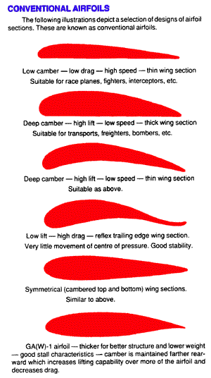
- Types of Drag
  - Parasite Drag
    - Drag of all parts of the airplane which do not contribute to lift
    - Can be minimized, but is difficult to eliminate
    - Two different types:
      - Form drag
        - Caused by the shape of the aircraft
          - Landing gear, antennas, struts, wing tip fuel tanks
      - Skin Friction
        - Friction produced by the air flowing over the body clinging to its surface
        - Ice or dirt build up contributes significantly
        - Aircraft are painted and rivets are often counter-sunk

  - Induced Drag
    - Caused by those parts of the airplane which actively produce lift
    - Cannot be eliminated
      - May be reduced with a high aspect ratio
- Wingtip Vortices
  - Due to pressure changes as air flows around the wing, air flows inward over the top (low pressure) and outward over the bottom (high pressure)
  - At the wing tip, a vortex is created
    - This produces a large portion of induced drag
  - This can be particularly intense behind large aircraft
    - Small aircraft must wait for a set period of time before landing or taking off behind large aircraft to avoid “wake turbulence” caused by the vortices
- Streamlining
  - Streamlining is shaping the aircraft to minimize drag.
  - Allows for less fuel consumption in powered aircraft
  - Allows for better glide characteristics in gliders

