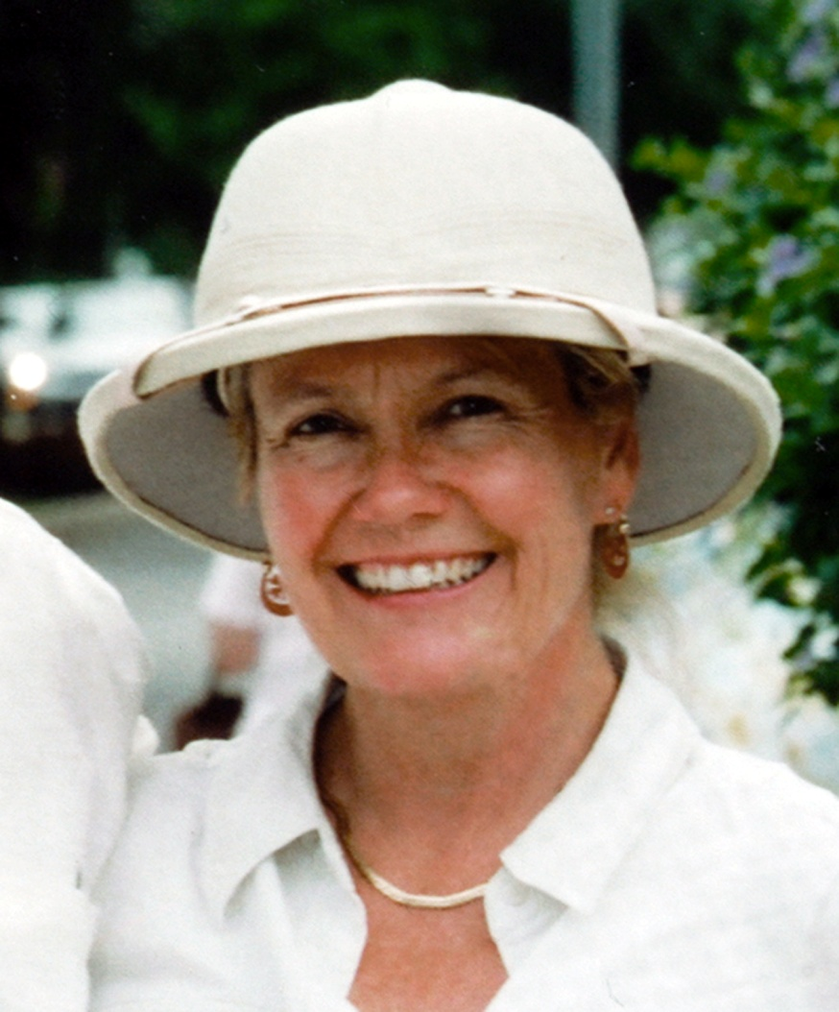
Lola Reid Allin
—Commercial Pilot—Author—Photographer—Scuba Dive Master—

https://www.lolareidallin.com

After exciting careers above earth as a pilot (>6000 hours) and below earth as a scuba Dive Master (500 dives), Lola became an award-winning photographer, author, and adventurer. Her work has been exhibited in Mexico, and in Canada at SPARK Photo Festival (Peterborough), Parrott Art Gallery (Belleville), CLIC Photo Show, (Picton), Nuit Blanche and CONTACT Photo Festival (Toronto).

Her work has appeared in a variety of notable publications (in print & online) including National Post, Globe & Mail, Toronto Star, The Rotarian, The Smithsonian, National Geographic, Photographers without Borders, & Skies Magazine.

~ ARMCHAIR ADVENTURES ~
To share her adventures & photographs, to inspire others to broaden their horizons, and to encourage other photographers to share their work, she created the ARMCHAIR TRAVELER TRAVELOGUE in 2017. Her personally-narrated PowerPoint presentations include the Modern Maya, Mayan Archaeology, Trek to the Snows of Kilimanjaro, Trek the Akshayuk Pass, Morocco, Chile, Women in Aviation, & Vietnam.

Virtually and in person, she has presented to the general public of all ages at libraries, galleries, schools, hotels, as well as private clubs or organizations (99s, Flight students, Air Cadets) and she is a speaker with the Northern Lights Aero Foundation, Eastern Ontario 99s Education & Outreach Committee, & Women’s Travel Network.

~ AFFILIATIONS ~ 99s, Women in Aviation, Northern Lights Aero Foundation, Quinte Arts Council, Belleville Art Association, Women’s Travel Network.

~ IN THE NEWS ~
2022 Lola creates the New Track Scholarship, East Canada Section 99s Canadian99s.com/scholarships-awards-2/
2021 SPARK Annual Juried Regional Photography Exhibition, Peterborough, Ontario
2020 Gotham Writers #GWStoriesEverywhere Contest Winner (November)
Pilot Alumni of Distinction Award, Waterloo Wellington Flight Centre
The Rotarian Magazine Annual Photography Contest, Honorable Mention
Belleville Art Association Annual Juried Art Show, Award for Creative Excellence
2019 Photographers without Borders Int’l Magazine Contest, 2nd Place
SPARK, 2nd Place
2018 Parrott Art Gallery, Belleville, Ontario Biennial Exhibition, Honorable Mention
SPARK 3rd Place
2017 SPARK 3rd Place
Santa Fe Centre for Photography “Summer vacation” Contest, Honorable Mention
FIND ME on Facebook - LinkedIn - Instagram - Twitter

