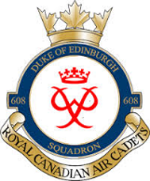

OTTAWA CITIZENSHIP TRIP
16 – 17 MARCH 2019

KIT LIST

*ALL CADETS MUST BRING THEIR HEALTH CARD and any prescribed medications*

CADETS WILL WEAR:
- Cadet Uniform:
- Tunic (with nametag and appropriate badges properly sewn on)
- Blue Shirt
- Tie
- Pants
- Belt
- Grey cadet socks
- Parade boots
- Wedge
- Parka with slip-ons

BRING:
- Appropriate clothing for Saturday evening activities at Connaught
- Socks and undergarments for Sunday
- Toiletry kit (soap, deodorant, toothbrush, toothpaste, shampoo, shaving kit – if applicable)
- Shower sandals
- Towel
- Appropriate sleepwear
- Sleeping bag or blanket, if you wish. Bedding is provided.

DO NOT BRING VALUABLES OR PROHIBITED ITEMS.

