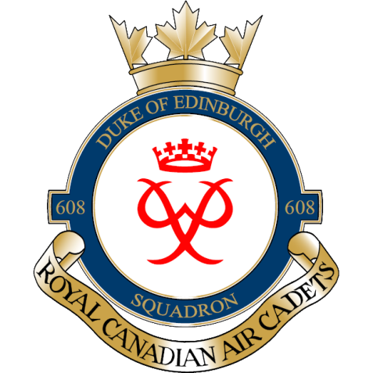

Hello Parents/Guardians,
On February 20th 2016, 608 Duke of Edinburgh will be participating in a ski day at Batawa Ski Hill.
Cadets are asked to be in the chalet at 9:30 am. We will be done at 4:00 pm. Cadets are responsible for their own rides and food for the day.
The cost for the day is $10.
On the following page is a participant consent waiver and information that needs be filled out.
If you have any questions don’t hesitate to ask.
Thanks,

Captain / capitaine Justin Leadbeater
Commanding Officer, RC(Air)CS 608 Duke of Edinburgh
National Defence / Government of Canada
Lead_beater@hotmail.com / Tel: 613-827-2320
Commandant, RC(Air)CS 608 Duke of Edinburgh
Défense nationale / Gouvernement du Canada
Lead_beater@hotmail.com / Tél: 613-827-2320

